Ankita Durgude

**Assignment –5**

**Relational and Logical Operators.**

**1) Write a query that will give you all orders for more than Rs. 1,000.**

**Ans: select * from orders where Amt>1000;**

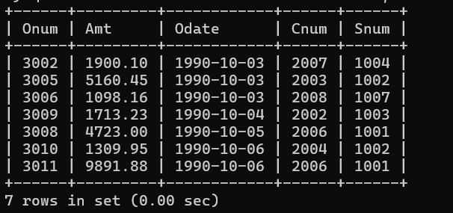

**2) Write a query that will give you the names and cities of all salespeople in**

**London with a commission above .10.**

**Ans:** select Sname, City from salespeople where City= 'London' and Comm>0.10;

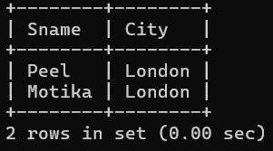

**3) Write a query on the Customers table whose output will exclude all customers with a rating <= 100, unless they are located in Rome.**

**Ans:** select * from customers where rating>=100 or city='Rome';

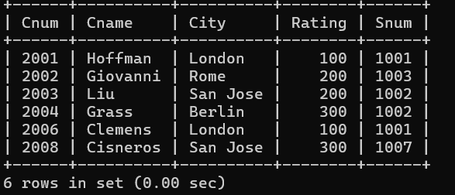

**4) What will be the output from the following query?**

**Select * from Orders**

**where (amt < 1000 OR**

**NOT (odate = ‘1990-10-03’**

**AND cnum > 2003));**

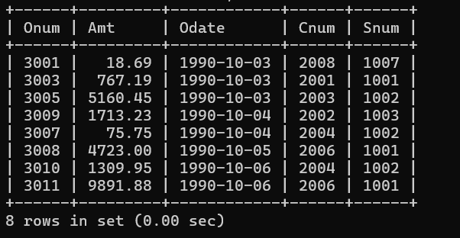

**Ans:**

**5) What will be the output of the following query?**

**Select * from Orders**

**where NOT ((odate = ‘1990-10-03’ OR snum**

**>1006) AND amt >= 1500);**

**Ans:**

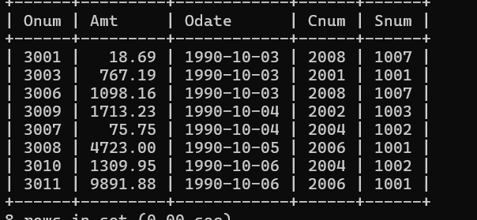

**6) What is a simpler way to write this query?**

**Select snum, sname, city, comm From Salespeople**

**where (comm > .12 OR comm <.14);**

Ans: Select * from Salespeople where comm <.14 ;

